ShopNest PowerBI Capstone Project:
ShopNest stands as the leading department store in the e-commerce marketplaces in Portugal. Serving as a seamless link, it connects small businesses from various regions in Portugal to channels, streamlining the process with a single point of contact. Through the ShopNest Store, these merchants can showcase and sell their products, with the added convenience of direct shipment to customers facilitated by ShopNest logistics partners. The provided data represents authentic commercial information that has undergone the process of anonymization.
This capstone has 9 datasets and the descriptions are below:
Customers_dataset:
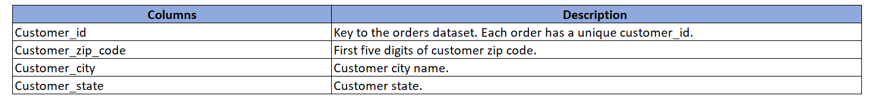
Geolocation_dataset:
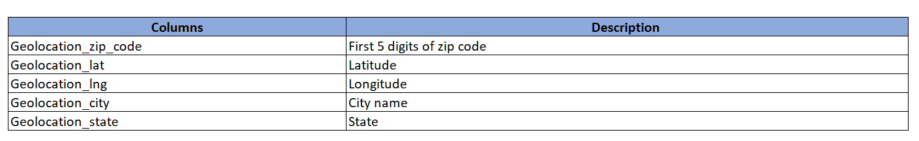
Order_items_dataset:
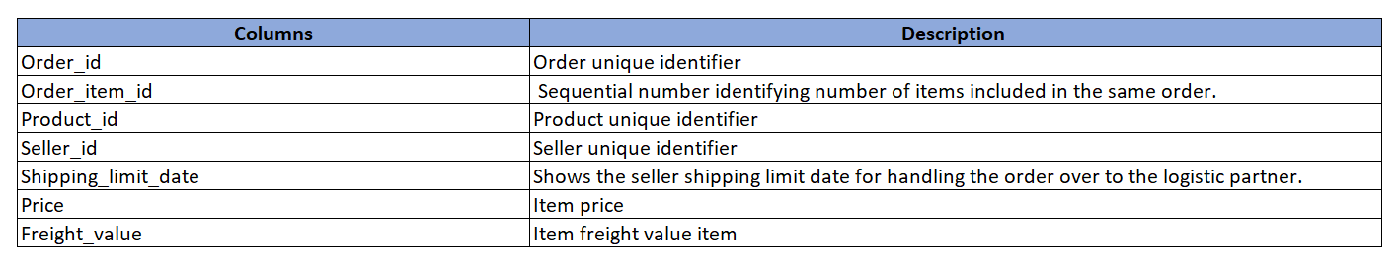
Order_payments_dataset:
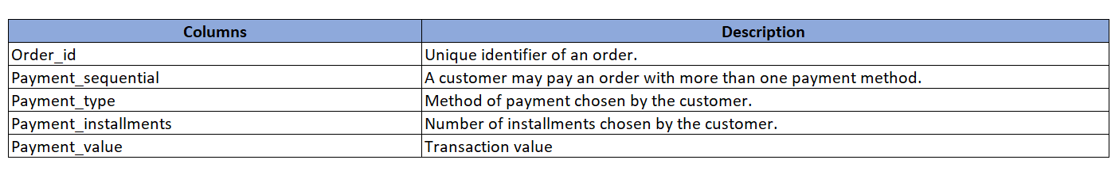
Order_reviews_dataset:
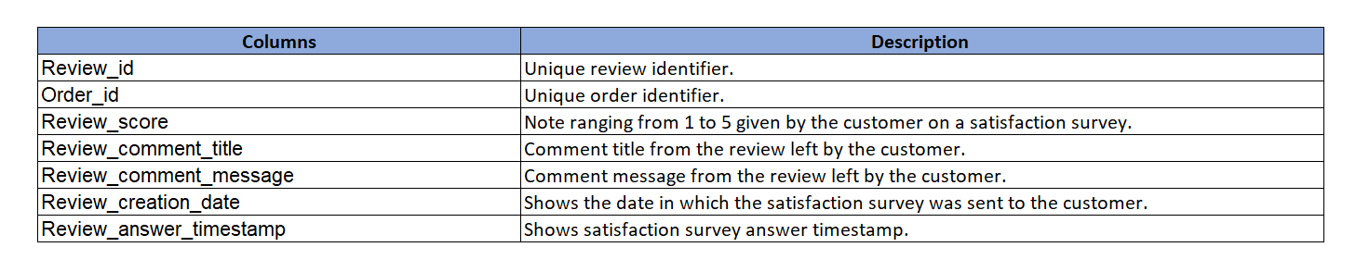
Orders_dataset:
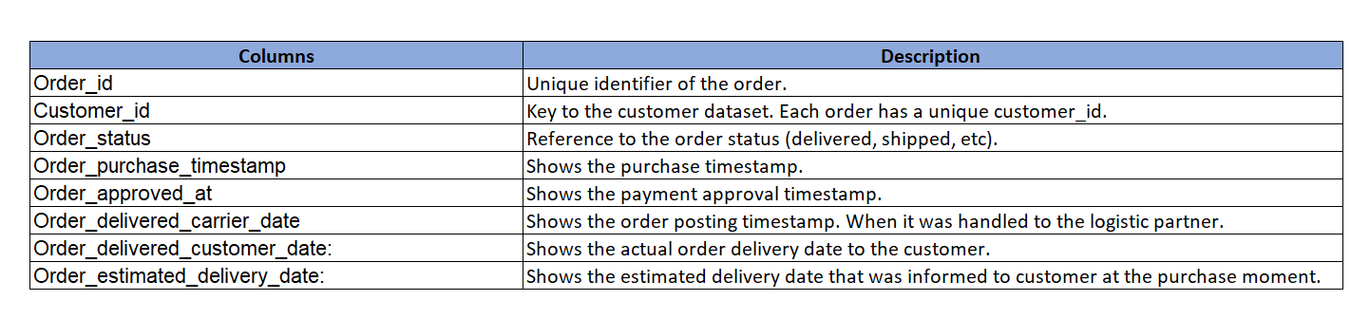
Products_dataset:
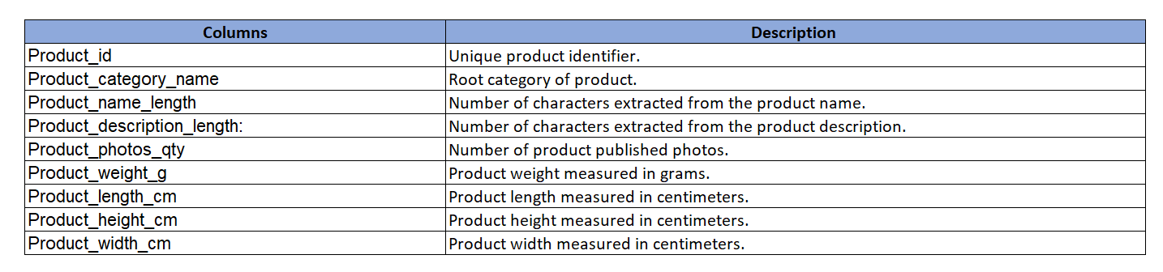
Sellers_dataset:
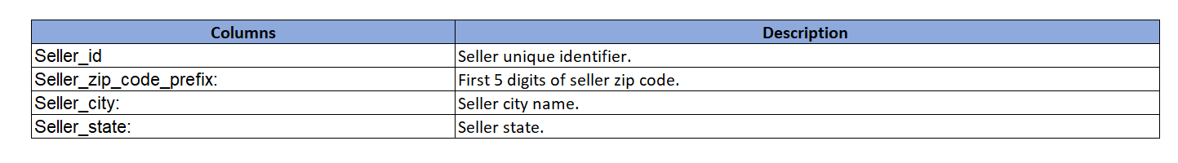
Product Categories:
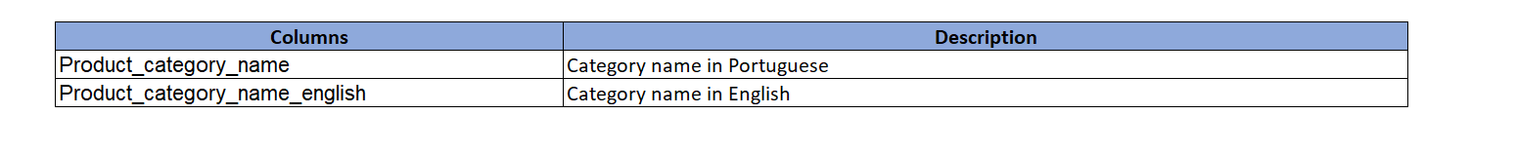
Tasks to do:
Design a comprehensive Power Bl dashboard to address key business analytics for a retail dataset. The following analytical questions should be answered through your dashboard:
1. Identify the rating distribution in the Shop_Nest dataset, showcasing ratings categorized as Excellent, Very Good, Good, Bad, and Very Bad, along with corresponding orders.
2. What are the top 10 and bottom 18 most popular product categories in the ShopNest dataset?
Please list them based on the number of orders.
3. List the total number of active sellers by yearly and monthly.
4. Which payment methods are most commonly used by ShopNest customers.
5. Identify the product category. wise profit margin using the formula
Hint: (Payment value -price + Freight_value)/payment_value*100 (Rounded to two decimal points).
6. Determine the monthly payments made by customers using credit cards.
7. Identify sellers categorized by city, excluding cities starting with the letters S and B.
8. ⁠Create a dynamic visual that compares the number of delayed orders to the number of orders received earlier for each month. Utilize the drill through the cross-report feature to provide a detailed analysis of late and on-time deliveries.

Instruction to submit the capstone:
1. PowerBI Dashboard (PBIX File):
• Provide the Power BI dashboard in a PBIX file format. Create a Power Bl dashboard in a single sheet that includes all the charts for the given 8 questions. The file should contain all necessary visualizations, slicers, and data connections for the analysis.
2. Dashboard Report (DOC File):
• Create a detailed report document in DOC format that explains the dashboard comprehensively.
• Include screenshots or images of the dashboard visuals in the document for a clear representation.
• For each question/task outlined in the Power BI Capstone Project, include a section with the following details:
• Question Statement: State the question/task.
• Visualization: Include an image of the corresponding visualizations) in the dashboard.
• Explanation: Provide a clear and concise explanation of the visual, highlighting key insights and findings.
• Ensure the document is organized, with each section corresponding to a specific question or aspect of the dashboard.
• Submit your capstone in the zip file containing the dashboard and report.

